Step 1. Setup Machine
Within this section, you will configure Earthworks to setup which machine type, make, model, and what equipment has been installed.
1. Enter and sign into the Web Interface application over the TD display or wifi
2. Navigate to the configure menu and to the Install Assistant Section
3. Release the service lock
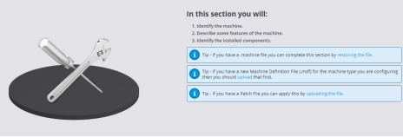
4. Enter the Setup Section and follow the on screen instructions

5. Name the machine (Usually model and customer machine number, etc). Also
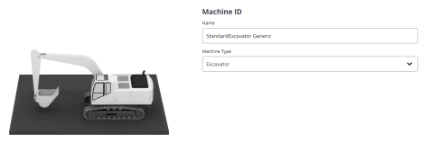
choose Machine Type.

6. Configure machine description settings such as Manufacturer, Size, Model, SN
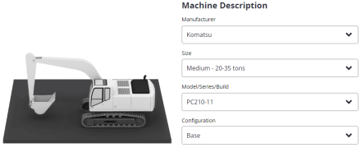
breaks, and Configuration:

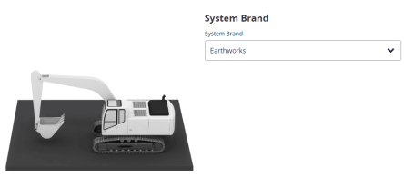
7. Select Earthworks as System Branding:

8. Configure Front Linkage Configuration such as Boom type, where the
Attachment sensor is located, and if there is a quick coupler installed on the
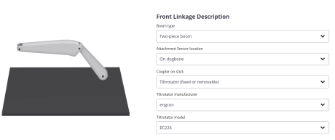
machine:
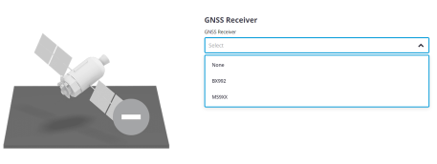
9. Select the GNSS Receiver to be used

10. Configure the 3D sensor mounting locations and if a Laser Catcher is installed:

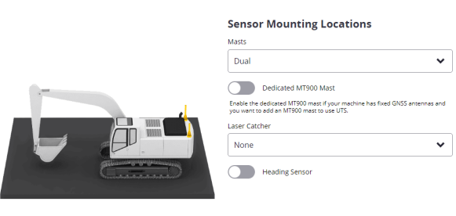
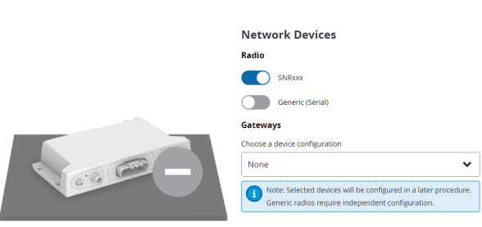
11. Configure Network devices such as the SNR radio and SNM941 Modem:

12. Enable Depth Automatics if the machine is equipped:
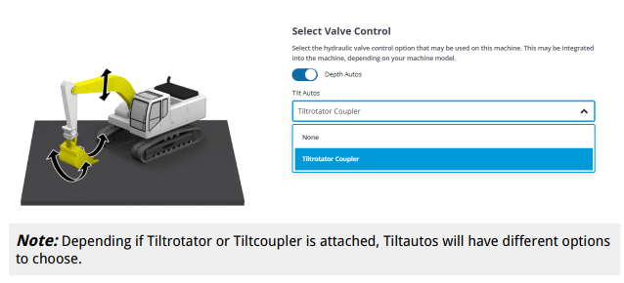
13. Configure optional devices such as External Lightbars, Remote Switches (Used
with Autos, and the AR camera:
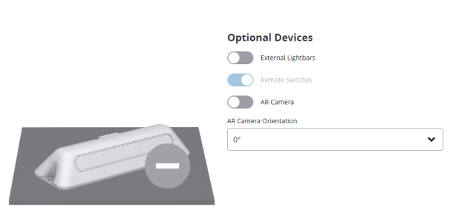
14. Configure the machine into the preferred distance units:
